OBONG UNIVERSITY, OBONG NTAK
NATURAL AND APPLIED SCIENCE
COMPUTER SCIENCE

A PROJECT REPORT
ON
DVELOPMENT OF A STUDENT HOSTEL MANAGEMENT SYSTEM

BY
UYOATTAH ABRAHAM UDOH
U1CS2214

A PROJECT SUBMITTED TO THE DEPARTMENT OF COMPUTER SCIENCE,
FACULTY OF NATURAL AND APPLIED SCIENCE,
OBONG UNIVERSITY,
IN PARTIAL FULFILMENT OF THE REQUIREMENTS FOR THE AWARD OF
BSc. IN COMPUTER SCIENCE

AUGUST 2026
CERTIFICATION
This is to certify that this project report titled "DVELOPMENT OF A STUDENT HOSTEL MANAGEMENT SYSTEM" was carried out by:
Name: UYOATTAH ABRAHAM UDOH
Matriculation Number: U1CS2214
under the supervision of:
Supervisor:
and is submitted in partial fulfilment of the requirements for the award of:
BSc. COMPUTER SCIENCE of the Department of COMPUTER SCIENCE, Faculty of NATURAL AND APPLIED SCIENCE.

Project Supervisor: MR. UNWANA THOMAS
Signature: ...........................................
Date: ...........................................

Head of Department: DR. KUFRE UKPE
Signature: ...........................................
Date: ...........................................

External Examiner:
Signature: ...........................................
Date: ...........................................
DECLARATION
I, UYOATTAH ABRAHAM UDOH, with Matriculation Number U1CS2214, hereby declare that this project report titled "DEVELOPMENT OF A STUDENT HOSTEL MANAGEMENT SYSTEM" is my original work and has not been submitted previously for the award of any degree or diploma in this or any other institution.
I further declare that all sources of information used in this project have been duly acknowledged by means of references and citations.

Student's Name: UYOATTAH ABRAHAM UDOH
Signature: ...........................................
Date: ...........................................

DEDICATION
This project is dedicated to Almighty God for His infinite grace, guidance, and strength throughout my academic journey.
To my beloved parents, whose unwavering support, sacrifice, and encouragement have been the cornerstone of my success. Your belief in my abilities has been my greatest motivation.
To my siblings and family, for their constant love and understanding during the challenging times of this project.
To all students who aspire to use technology to solve real-world problems, may this work inspire you to pursue excellence.

ACKNOWLEDGEMENT
First and foremost, I return all glory and adoration to Almighty God for His divine guidance, protection, and wisdom throughout the course of this project. Without His grace, this work would not have been possible.
I wish to express my profound gratitude to my supervisor, MR. UNWANA THOMAS, for the invaluable guidance, constructive criticism, patience, and encouragement provided throughout the duration of this project.
My sincere appreciation goes to the Head of Department, DR. KUFRE UKPE, and all the academic and non-academic staff of the Department of COMPUTER SCIENCE, OBONG UNIVERSITY. Your commitment to nurturing young minds and equipping us with relevant skills is highly commendable. Special thanks to my lecturers who have imparted knowledge and shaped my understanding of Computer Science and Information Technology over the years.
My heartfelt appreciation goes to my parents, for their unconditional love, financial support, and prayers. Your sacrifices have brought me this far, and I am forever indebted to you. To my siblings and extended family members, thank you for your encouragement and for believing in my dreams.
I acknowledge my friends, classmates, and colleagues who provided support, motivation, and technical assistance during the development and testing of this system. Your camaraderie and shared experiences made this journey memorable.
Lastly, I extend my gratitude to all whose names may not have been mentioned but who contributed in one way or another to the successful completion of this project. God bless you all.

ABSTRACT
The administration of student hostels in many Nigerian universities continues to rely on outdated manual methods that create significant challenges for both students and staff. Room allocation involves stressful queues and cumbersome paperwork, often resulting in errors such as double allocation of beds, leading to conflicts and a poor start to the academic session. Attendance tracking using paper logbooks is unreliable, easily falsified, and susceptible to loss, compromising security and making it difficult to determine who is inside the hostel at any given moment. Maintenance complaints reported verbally or on paper slips frequently disappear, leaving issues unresolved and facilities in a state of decay. These interconnected problems undermine student welfare and institutional effectiveness.
This project aimed to design and develop a Student Hostel Management System incorporating rule-based room allocation, QR code attendance tracking, and complaint management to address these challenges. The system was developed using the Agile Software Development Methodology with the Scrum framework, combining qualitative and quantitative research methods including interviews, surveys, and document analysis to gather requirements.
The system was implemented using a three-tier client-server architecture. The frontend was developed with React.js, Redux Toolkit, and Tailwind CSS, providing responsive interfaces for students, administrators, and porters. The backend was implemented using Node.js and Express.js, with JWT for authentication, Bcrypt for password hashing, and Nodemailer for email functionality. MongoDB served as the database management system, with Mongoose as the ODM library, hosted on MongoDB Atlas. The system was deployed using Vercel for the frontend and Railway for the backend.
The implemented system features rule-based allocation that automatically enforces gender separation, first-come-first-served processing, and student level priority. QR code technology enables fast and reliable check-in and check-out, providing real-time occupancy monitoring. The complaint management module allows students to submit maintenance issues online and track resolution progress through pending, read, in progress, and done stages. Database validation prevents double allocation through unique constraints and atomic update operations.
System testing covering functional, validation, integration, and user interface testing was conducted in a controlled environment using simulated data. All test cases executed successfully, confirming the reliability of registration, authentication, allocation, QR attendance, complaint management, and role-based access control. The performance evaluation indicated acceptable response times for typical operations.
The project successfully demonstrated that an integrated web-based hostel management system can eliminate long queues, reduce errors, enhance security through real-time occupancy monitoring, ensure complaints are properly tracked, and offer transparency through a centralized platform. The system provides a practical digital solution that addresses the inefficiencies, errors, security concerns, and lack of transparency associated with manual hostel administration in Nigerian universities.
Keywords: Student Hostel Management System, Rule-Based Allocation, QR Code, Attendance Tracking, Complaint Management, Web-Based System, MongoDB, Hostel Administration, React.js, Node.js.

TABLE OF CONTENTS
Cover Page
Certification
Declaration
Dedication
Acknowledgement
Abstract
Table of Contents
List of Tables
List of Figures
List of Abbreviations
CHAPTER ONE: INTRODUCTION
1.1 Background To The Study
1.2 Statement Of The Problem
1.3 Aim And Objectives Of The Study
1.4 Significance Of The Study
1.5 Scope Of The Study
1.6 Limitations To The Study
1.7 Definition Of Terms
CHAPTER TWO: REVIEW OF RELATED LITERATURE
2.1 Conceptual Review
2.1.1 Information System
2.1.2 Hostel Management System
2.1.3 Rule-Based Allocation System
2.1.4 QR Code Technology
2.1.5 Attendance Tracking System
2.1.6 Complaint Management System
2.1.7 Web-Based Systems
2.1.8 Database Management System
2.2 Review of Related Empirical Studies
2.3 Review Of Existing Systems
2.3.1 Manual Hostel Allocation System
2.3.2 Spreadsheet-Based Hostel Management
2.3.3 Existing QR Code Attendance Systems
2.3.4 Existing Complaint Management Systems
2.3.5 Existing Hostel Management Applications
2.4 Gap In Literature
2.5 Summary Of Reviewed Literature
CHAPTER THREE: SYSTEM ANALYSIS AND DESIGN
3.1 Analysis Of The Existing System
3.1.1 Architecture Of The Existing System
3.1.2 Constraints Of The Existing System
3.2 Analysis Of The Proposed System
3.2.1 Justification Of The Proposed System
3.3 Method Adopted In The Study
3.3.1 Research Methodology
3.3.2 Research Approach
3.3.3 Development Tools
3.4 System Design
3.4.1 Architecture Of The Proposed System
3.4.2 High Level Input Design
3.4.3 High Level Output Design
3.5 Database Design Of The Proposed System
3.5.1 Entity-Relationship Diagram (ERD)
3.5.2 Database Schema Description
3.5.3 Database Relationships Summary
3.5.4 Database Indexes
3.6 Summary Of Chapter Three
CHAPTER FOUR: SYSTEM IMPLEMENTATION
4.1 Choice Of Implementation Platform
4.1.1 Frontend Platform
4.1.2 Backend Platform
4.1.3 Database Platform
4.1.4 Deployment Platform
4.1.5 Justification Of Implementation Platform
4.2 Implementation Architecture
4.2.1 Student And User Management
4.2.2 Hostel And Room Management
4.2.3 Rule-Based Room Allocation
4.2.4 QR Code Attendance Tracking
4.2.5 Complaint Management
4.2.6 Database Implementation
4.3 System Testing
4.4 Performance Evaluation
4.5 Discussion Of Results
4.6 Documentation
4.7 System Setup And User Manual
4.7.1 System Requirements
4.7.2 System Setup
4.7.3 Student User Manual
4.7.4 Administrator User Manual
CHAPTER FIVE: SUMMARY, CONCLUSION AND RECOMMENDATION
5.1 Summary
5.2 Conclusion
5.3 Recommendations
5.4 Suggestions For Future Studies
REFERENCES
APPENDICES
APPENDIX A: SOURCE CODE
APPENDIX B: SYSTEM SNAPSHOTS

LIST OF TABLES

Table 3.1 — Constraints Of The Existing System
Table 3.2 — Justification Of The Proposed System
Table 3.3 — High Level Input Design
Table 3.4 — High Level Output Design
Table 3.5 — Users Collection Schema
Table 3.6 — Hostels Collection Schema
Table 3.7 — Buildings Collection Schema
Table 3.8 — Rooms Collection Schema
Table 3.9 — Bunks Collection Schema
Table 3.10 — CheckIns Collection Schema
Table 3.11 — Complaints Collection Schema
Table 3.12 — Transactions Collection Schema
Table 3.13 — Database Relationships Summary
Table 3.14 — Database Indexes
Table 4.1 — System Test Cases And Results
Table 4.2 — Performance Evaluation Summary

LIST OF FIGURES

Figure 3.1 — Architecture Of Existing System
Figure 3.2 — Agile Development Process
Figure 3.3 — Proposed System Architecture
Figure 3.4 — Entity-Relationship Diagram
Figure B.1 — Student Login Interface
Figure B.2 — Complaint Submission Interface
Figure B.3 — Administrator Dashboard
Figure B.4 — Hostel, Building And Room Management Interface
Figure B.5 — Attendance Monitoring Interface
Figure B.6 — Administrator Complaint Management Interface

LIST OF ABBREVIATIONS

API — Application Programming Interface
DBMS — Database Management System
ERD — Entity-Relationship Diagram
HND — Higher National Diploma
HTML — HyperText Markup Language
JWT — JSON Web Token
NGN — Nigerian Naira
ODM — Object Data Modeling
OTP — One-Time Password
QR — Quick Response
RAM — Random Access Memory
REST — Representational State Transfer
SQL — Structured Query Language
UI — User Interface
URL — Uniform Resource Locator
2FA — Two-Factor Authentication

CHAPTER ONE
INTRODUCTION

1.1 Background To The Study
Moving to college is a major transition, especially for students leaving home for hostels. Well-managed accommodation provides safety and stability, allowing students to focus on academics without commuting or household distractions. Proximity to lecture halls saves time, making efficient hostel administration vital for student success.
Yet hostel management has grown far more complex. Enrolment has surged while bed capacity has stayed fixed, overwhelming both students and staff. Tasks once simple now require handling thousands of students with limited spaces and reams of paperwork.
Many Nigerian universities still operate manually. Room allocation means long queues and paper forms. Logbooks for tracking movement are easily lost or falsified. Maintenance complaints are reported verbally or on slips that frequently disappear, leaving issues unresolved and facilities in decay.
These outdated methods cause serious problems. Students queue for days during allocation. Paperwork is slow and error-prone, sometimes double-allocating beds and sparking conflicts. Records are hard to secure or retrieve. Security suffers because occupancy is poorly tracked. Maintenance delays frustrate students and erode trust between residents and staff.
Digital transformation offers a clear solution. A Hostel Management System automates operations—saving time, reducing errors, and improving user experience. It unifies room allocation, movement tracking, and complaint handling on one platform.
Key features include rule-based allocation: the system assigns rooms by predefined criteria (e.g., first-come-first-served, student level, or final-year priority) and automatically enforces gender separation, ensuring fairness and eliminating administrative mistakes.
Another vital feature is QR code technology, a two-dimensional barcode scannable by mobile devices. Each student gets a unique code. Scanning it at the entrance instantly logs entry or exit, providing real-time occupancy data that boosts safety and enables rapid emergency roll calls.
The system also digitises complaint management. Students submit maintenance issues online and receive a tracking number. Each complaint is routed to the right personnel, and status updates, "submitted", "in progress", "resolved", are visible to students. This transparency ensures accountability and stops complaints from being overlooked.
This project proposes a web-based Hostel Management System with three integrated components: rule-based room allocation for fair bed distribution, QR code check-in for security, and a complaint management system for prompt maintenance. Together, they replace inefficient manual processes with a seamless digital platform for staff and students.

1.2 Statement Of The Problem
Student hostel administration in many Nigerian universities faces major challenges from continued reliance on manual methods. The foremost issue is inefficient, error-prone room allocation. Each session, students endure stressful queues and bulky paperwork that waste huge amounts of time. This exhausting process often leads to serious errors like double bed allocation, causing conflicts and a poor start to the academic year.
A second critical problem is inadequate monitoring of hostel entry and exit. Paper logbooks are unreliable, easily falsified, lost, or damaged. Consequently, it is nearly impossible to know exactly who is inside the hostel at any moment, raising genuine security concerns, especially during emergencies like fires when rapid headcounts are essential.
The manual system also fails badly in maintenance management. Reporting a broken fan or leaking pipe is slow and opaque. Students have no assurance that their issue will be properly recorded, assigned, or addressed promptly. Without proper tracking, complaints are often forgotten or neglected, causing facilities to worsen and students to endure poor living conditions.
Finally, the whole system lacks transparency and effective communication. There is no central platform for updates on allocations or complaint progress. Students feel frustrated and ignored, while staff struggle with piles of paper and constant interruptions, making efficient management impossible. These interconnected problems undermine both student welfare and institutional effectiveness. A clear need exists for a digital hostel management system that automates these tasks, eliminates human error, and offers a transparent, secure platform for all.

1.3 Aim And Objectives Of The Study
The primary aim is to design and develop a Student Hostel Management System incorporating rule-based room allocation, QR code attendance tracking, and complaint management.
The specific objectives are:
- Develop a digital system for allocating hostel rooms to students.
- Implement allocation rules including first-come-first-served, student level, and gender separation.
- Implement automatic database validation to prevent double allocation of rooms and beds.
- Create a QR code check-in and check-out system for hostel entry and exit.
- Develop accurate digital records of student movement in and out of the hostel.
- Implement a complaint system for reporting repair and maintenance issues.
- Provide real-time complaint status tracking for students.
- Evaluate the system's effectiveness in improving communication between students and staff through a central announcement platform.
- Test the system's functionality and performance in a controlled environment.

1.4 Significance Of The Study
This project will benefit multiple stakeholders. For students, it eliminates stressful queues and manual allocation, they can secure bed spaces remotely via the internet. QR code-based check-in enhances personal security, while the complaint module empowers them to report issues and track resolution, improving overall living conditions.
For administrators and porters, the system revolutionises workflow by removing burdensome paperwork. It significantly reduces errors and provides a powerful dashboard for real-time occupancy and movement monitoring, enabling more strategic management. Institutional leadership gains reliable data for planning and resource allocation. Transparent processes protect the institution's reputation. Maintenance staff receive clear, prioritised task lists with formal feedback mechanisms, boosting efficiency and accountability. Finally, the project serves as a valuable reference for researchers and future developers studying digital administration systems in Nigerian higher education.

1.5 Scope Of The Study
This study focuses on developing a web-based Student Hostel Management System with three primary modules: Rule-Based Hostel Allocation, QR Code-Based Attendance Tracking, and Complaint Management. The system has two user interfaces. The student interface enables room applications, payment processing, room detail viewing, QR code access, and complaint submission. The administrator interface allows hostel and room management, allocation rule configuration, real-time attendance monitoring, and complaint handling.
The study excludes online payment gateway integration; payment confirmations are processed manually by administrators. Advanced biometric systems (fingerprint or facial recognition) are not included. GPS-based location tracking outside the hostel is outside scope. Artificial intelligence for predictive accommodation needs is not incorporated. The system operates as a standalone application, so integration with other institutional systems (academic records or finance) is not covered.

1.6 Limitations To The Study
Several limitations affected this project. Time constraints within the final-year academic calendar limited testing and refinement. Financial restrictions limited access to premium software, large-scale hosting, and advanced QR scanning hardware.
The system requires stable internet and server infrastructure; performance may degrade in areas with poor network coverage, a common challenge in Nigeria. Access to actual university hostel data for testing was challenging, so simulated data was used, which may not perfectly reflect real conditions. Additionally, the system was tested in controlled, small-scale environments; its performance under heavy concurrent user loads typical of large institutions could not be fully validated.

1.7 Definition Of Terms
Hostel Management System: Software that automates daily hostel operations including room allocation, record keeping, and maintenance requests.
Rule-Based Allocation: Automated assignment of hostel spaces based on predetermined criteria rather than manual decision-making.
QR Code: Two-dimensional barcode containing student identification data, scannable by mobile devices.
Attendance Tracking: Recording student entries and exits through QR code scanning to log check-in and check-out times.
Complaint Management System: Digital tool enabling users to report problems, track resolution progress, and receive feedback.
Student Module: User-facing component enabling students to apply for rooms and submit complaints.
Administrator Module: Back-end interface allowing managers to configure rules, manage allocations, view attendance logs, and handle complaints.
Check-In / Check-Out: Scanning QR code to record student entry into or departure from the hostel.

CHAPTER TWO
REVIEW OF RELATED LITERATURE

2.1 CONCEPTUAL REVIEW
2.1.1 INFORMATION SYSTEM
An information system is a combination of parts that work together to collect, store, process, and share data to help people make decisions (Saylor Academy, 2021). It is not just about computers. It includes people, processes, and technology all working as one.
The main components of an information system are hardware, software, databases, networks, and people (Saylor Academy, 2021). Hardware means the physical parts like computers and scanners. Software means the programs that tell the hardware what to do. Databases store all the information in an organized way. Networks allow different parts to talk to each other. People are the most important part because they use the system to get things done.
Information systems are very important in modern life. They turn raw data into useful information that helps organizations run better. For example, instead of having paper files scattered everywhere, an information system keeps everything in one digital place where it is easy to find and use (Okonkwo & Ibrahim, 2021).
In organizations, information systems play many roles. They help with daily operations like keeping records. They help managers make better decisions by giving them accurate and timely information. They also help organizations talk to their customers and partners. A good information system can save time, reduce mistakes, and make work more efficient.
The benefits of digital systems are clear. They reduce human error because computers do calculations automatically. They save time because tasks that took hours can now take seconds. They improve security because data can be protected with passwords and backups. They also make information easy to share across different departments (Shaheen, 2016).

2.1.2 HOSTEL MANAGEMENT SYSTEM
A hostel management system is a software application designed to handle the daily activities involved in running a student hostel (Ohayi, 2025). These activities include allocating rooms, keeping records of students, tracking who comes in and out, handling complaints, and managing payments.
The purpose of a hostel management system is to make hostel administration easier, faster, and more reliable. Instead of using paper files and manual processes, the system does everything digitally. This means less stress for staff and better service for students (Shaheen, 2016).
Traditional hostel administration in many Nigerian schools still relies on manual methods. Room allocation is done with paper forms and long queues. Attendance is tracked in logbooks that can be lost or damaged. Complaints are written on slips of paper that often go missing. This old way of doing things has been around for decades, but it no longer works well with the large number of students in schools today (Okonkwo & Ibrahim, 2021).
The problems associated with manual methods are many. First, there is the issue of slow processing. Students spend days waiting in line just to get a bed space. Second, there is the problem of errors. Manual records can have mistaken like double allocation where two students get assigned the same bed. Third, there is poor security. Without proper tracking, it is hard to know who is inside the hostel at any time. Fourth, there is the issue of lost complaints. When students report a broken tap or a faulty fan, their complaint may never reach the maintenance team (Ohayi, 2025).
Computerized hostel management offers many benefits. It speeds up room allocation because the system can assign rooms automatically based on set rules. It reduces errors because the database checks for conflicts before assigning a room. It improves security because every entry and exit can be logged digitally. It also makes complaint handling transparent because students can track the status of their reports online (Shaheen, 2016).

2.1.3 RULE-BASED ALLOCATION SYSTEM
A rule-based allocation system is an automatic process where the computer assigns hostel spaces using set rules instead of human decisions (Ibrahim et al., 2020). The system follows predefined conditions to decide which student gets which room.
Allocation rules are very important because they ensure fairness. When rules are applied consistently, every student is treated the same way. There is no room for favoritism or corruption. The system does not care who a student knows or how much they can pay under the table. It only follows the rules that have been set by the school administration (Okonkwo & Ibrahim, 2021).
There are several common types of allocation rules. First-come-first-served is the simplest rule. Students who apply early get priority over those who apply late. This rewards students who are organized and quick to act. Many Nigerian universities use this method for hostel allocation because it is easy to understand and implement.
Gender restrictions are another important rule. Most schools’ separate male and female students in different hostels or different sections of the same hostel. A rule-based system can automatically ensure that boys and girls are not mixed together. The system checks the student's gender and only shows them rooms that are appropriate for them (Ohayi, 2025).
Student level is also used as an allocation rule in many schools. Final-year students may be given first choice because they need to focus on their projects and exams. New students may be grouped together to help them settle in. Some schools also give priority to students from faraway states who have no relatives nearby to stay with.
Department or faculty can also be used as a rule. Some hostels are reserved for students from specific departments. The system can check a student's department and only allocate rooms in the appropriate hostel. This helps students stay close to their lecture halls and laboratory buildings.
Rule-based allocation reduces errors and improves fairness in several ways. First, it removes human bias from the allocation process. Second, it prevents double allocation because the system checks if a room is already taken before assigning it. Third, it creates an audit trail so administrators can see exactly how each room was assigned. Fourth, it saves time because no one has to argue about who deserves which room - the rules decide automatically (Ibrahim et al., 2020).

2.1.4 QR CODE TECHNOLOGY
QR code stands for Quick Response code. It is a two-dimensional barcode that can hold a lot of information in a small square shape (Onyema, 2019). Unlike the traditional barcodes you see on products, which only hold a few numbers, a QR code can hold hundreds of characters including letters, numbers, and even website links.
The history of QR codes goes back to 1994 in Japan. A company called Denso Wave created them to track car parts in factories. The traditional barcodes used at the time could only hold 20 characters, which was not enough for the detailed information needed in car manufacturing. The QR code was invented to solve this problem. The name "Quick Response" comes from the fact that the code can be scanned and read very quickly (Onyema, 2019).
QR codes have several important features. They can store different types of data including numbers, text, and web addresses. They have error correction built in, which means even if part of the code is damaged or dirty, it can still be read. They can be scanned from any angle because of the position markers in three corners of the square. They are also very small for the amount of information they hold.
The advantages of QR codes are many. They are cheap to produce because you can generate them for free online and print them on paper. They are fast to scan - much faster than typing a long number manually. They are secure because the information inside can be encrypted. They do not require special equipment because most modern phones have cameras that can scan them. They are also durable because even if the code gets a little damaged, it can still be read.
In education and security, QR codes have many uses. Schools use them to take attendance, manage library books, and control access to buildings. For hostel management, QR codes can be used to identify each student uniquely. When a student enters or leaves the hostel, they scan their code and the system logs the time instantly. This is much faster and more reliable than signing a paper logbook (Onyema, 2019).
For attendance and access control systems, QR codes work very well. Each student gets a unique code that is linked to their profile in the database. When they scan the code at a checkpoint, the system checks if they are a legitimate student and records the time of entry or exit. This creates a real-time record of who is inside the building, which is very useful for security and for taking attendance (Onyema, 2019).

2.1.5 ATTENDANCE TRACKING SYSTEM
An attendance tracking system is a method of recording when a person arrives and leaves a place. In the context of a hostel, it means recording when students enter and exit the hostel building (Muneeb1030, 2024).
Traditional attendance methods include paper logbooks and signature sheets. A student writes their name, the time they arrived, and the time they left. The porter or security guard watches them do this. This method has been used for many years, but it has serious problems. Logbooks can be lost, pages can be torn out, and signatures can be faked. It is also slow when many students are trying to enter at the same time, like after lectures end for the day.
Electronic attendance systems use technology to solve these problems. Instead of writing names manually, students use cards, fingerprints, or QR codes to check in. The system records the time automatically and stores it in a database. There is no chance of forgetting to write, writing illegibly, or faking an entry because the system is automated (Muneeb1030, 2024).
Attendance monitoring is very important for several reasons. First, it helps with safety. If there is an emergency like a fire, the hostel management needs to know exactly who is inside so they can be accounted for. Second, it helps with discipline. Parents and school administrators want to know if students are coming back to the hostel at reasonable hours. Third, it helps with planning. Knowing when students are usually in the hostel helps staff schedule cleaning and maintenance work.
Real-time attendance systems are the modern standard. Unlike old systems where attendance was recorded on paper and entered into a computer hour or days later, real-time systems update instantly. As soon as a student scans their QR code, the record appears in the system. Anyone with permission can see right away who is inside and who is outside. This is very useful for parents who want to know if their child has returned from lectures safely, and for administrators who need to do headcounts during emergencies.
The benefits of digital attendance records include accuracy, speed, security, and ease of analysis. Digital records are accurate because the computer records the exact time without human error. They are fast because scanning a code takes one second instead of ten seconds to write. They are secure because they cannot be easily altered after the fact. They are also easy to analyze because you can run reports to see patterns like which students come back late most often (Eneh & Ugwu, 2022).

2.1.6 COMPLAINT MANAGEMENT SYSTEM
A complaint management system is a digital tool that lets users report problems, track progress, and get feedback on their complaints (Eneh & Ugwu, 2022). In a hostel, this means students can report things like broken taps, faulty fans, leaking roofs, or broken beds.
Complaint handling is very important for maintaining good living conditions. When students live in a hostel, they expect basic things to work. A bathroom without water or a room without light is not acceptable. But in many Nigerian schools, complaints take weeks or months to be addressed, if they are addressed at all. This makes students frustrated and angry, and it damages trust between students and the school administration (Anusiuba et al., 2021).
A proper complaint management system follows a clear life cycle. The first stage is when the complaint is submitted. The student fills out a form online, describing the problem and maybe uploading a picture. The system gives the complaint a unique number for tracking.
The second stage is acknowledged. The system sends an automatic message to the student confirming that their complaint has been received. This is important because the student now has proof that they reported the problem. In manual systems, complaints often disappeared without a trace. The student had no way of knowing if anyone had seen their report.
The third stage is in progress. The complaint has been assigned to a maintenance worker who is working on it. The student can check the system and see that someone is dealing with their problem. This gives them peace of mind.
The fourth stage is resolved. The maintenance worker has fixed the problem. They update the system to say the work is done. The student is notified and can confirm that the problem is actually fixed.
The fifth and final stage is closed. The student confirms the problem is fixed, or the administrator closes it after verifying. The complaint record stays in the system for future reference.
Complaint management improves maintenance response in several ways. It creates accountability because every complaint has a responsible person assigned to it. It provides transparency because students can see the status of their complaint anytime. It enables prioritization because urgent problems like no water can be flagged and handled first. It also helps with reporting because administrators can see which types of complaints are most common and plan maintenance budgets accordingly (Anusiuba et al., 2021).
Communication is also greatly improved by a complaint system. Instead of students chasing staff members around or leaving notes that get ignored, everything happens through the system. Students get automatic updates when their complaint status changes. Staff can message students through the system to ask for clarification. This creates a clear record of all communication related to each complaint (Eneh & Ugwu, 2022).

2.1.7 WEB-BASED SYSTEMS
A web-based application is a software program that runs in a web browser like Chrome or Firefox. Unlike traditional software that you have to install on each computer, web-based systems live on a server and can be accessed from any device with an internet connection (Nwekori & Ogbaga, 2025).
The features of web applications include accessibility from anywhere, no installation required, automatic updates, and centralized data storage. You do not need to install anything on your computer - just open your browser and go to the website. Updates happen on the server, so you always have the latest version without clicking "install update." All data is stored centrally, so you can access the same information from your phone, your laptop, or a computer in the school library.
The advantages of web-based systems are significant. They are platform independent, meaning they work on Windows, Mac, Linux, Android, and iOS equally well. They are easy to maintain because changes only need to be made in one place - the server. They are scalable, meaning you can add more users without changing the software. They also make collaboration easy because multiple people can access and update the same data from different locations.
In educational institutions, web applications are very suitable. Students already have smartphones and laptops. They know how to use browsers. Schools have computer labs with internet access. A web-based hostel management system means students can apply for rooms, check their allocation status, and report complaints from their phones without having to go to an office and stand in line (Nwekori & Ogbaga, 2025).
For hostel management specifically, a web-based system is ideal because the users are not all in one place. Students may be in their rooms, in the library, or at home during holidays. Staff may be in their offices or doing inspections around the campus. A web-based system allows everyone to access the information they need from wherever they are, as long as they have an internet connection (Ohayi, 2025).

2.1.8 DATABASE MANAGEMENT SYSTEM
A database management system, or DBMS, is software that helps create, store, organize, and retrieve data from a database. It is the engine behind almost every modern application that stores information (Muneeb1030, 2024).
The importance of databases cannot be overstated. Without a database, information would have to be stored in separate files on different computers. Finding a specific piece of information would be slow and difficult. With a database, all information is stored in one place in an organized way. You can search, filter, and sort data very quickly.
Relational databases are the most common type of DBMS. They organize data into tables that look like spreadsheets. Each table holds a specific type of information. For example, a hostel database might have a student table, a room table, a complaint table, and an attendance table. The tables are connected, or related, by common fields. The student table connects to the attendance table because both tables have a student ID number. This allows the system to answer complex questions like "show me all attendance records for students in room 204" (Muneeb1030, 2024).
Data storage and retrieval are the two main jobs of a DBMS. When a student submits a complaint, the system stores that complaint in the database. When the student later wants to check the status of their complaint, the system retrieves that record from the database and displays it. This seems simple, but doing it fast and reliably for thousands of users at the same time requires a good DBMS.
In hostel management systems, databases are essential. The system needs to keep track of students, rooms, allocations, attendance logs, complaints, and much more. All of this data must be stored securely, retrieved quickly, and kept consistent so that there are no conflicts. For example, when allocating a room, the database must check that the room is empty before assigning it to a student. This prevents the problem of double allocation where two students get the same bed (Shaheen, 2016).

2.2 REVIEW OF RELATED EMPIRICAL STUDIES
Several researchers have studied hostel management systems and related topics. This section reviews previous studies to understand what has been done and where gaps remain.
Ohayi (2025) conducted a study titled "Design and Implementation of an Online Hostel Management System" at Abia State Polytechnic, Aba. The aim was to develop software that automates hostel activities including room allocation, mess expenditure, and attendance tracking. The researcher used SSADM methodology. The findings showed that the digital system reduced human error, improved security, and made record keeping easier. However, the study did not include QR code technology or a complaint tracking module. The system still required some manual input for certain tasks.
Anusiuba, Karim, Ekwealor, and Igbonekwu (2021) worked on "Design and Implementation of a Tertiary Institution Web-Based Student Complaint Management System." Their goal was to create a system where students could report concerns easily and track the progress of their complaints. They used the Waterfall methodology with PHP, JavaScript, HTML, CSS, and MySQL. The major finding was that a computerized complaint system gives students the ability to air concerns without fear. Students could also keep accurate track of complaints made. The limitation was that this system focused only on complaints and did not address room allocation or attendance tracking.
Nwekori and Ogbaga (2025) studied "Design and Implementation of a Web-Based Food Ordering Platform for Academic Environments" at Ebonyi State University. While not directly about hostels, this study is relevant because it showed how web-based systems can improve service delivery in university settings. They used Rapid Application Development methodology. The findings revealed that digital platforms significantly reduced processing time and minimized errors compared to traditional manual methods. The limitation was that the study focused on food services rather than accommodation.
Okonkwo and Ibrahim (2021) examined the impact of digital systems on university administration in Nigeria. Their study looked at how computerized systems improved efficiency in various departments. They found that digital systems reduced paperwork, sped up processes, and improved data accuracy. They also noted that many Nigerian universities still rely heavily on manual methods despite the clear benefits of digital systems. The limitation of their work was that it was more general and did not focus specifically on hostel management.
Shaheen (2016) wrote about "Hostel Management System" as a general concept. The work described how software can manage various activities in a hostel and avoid problems that occur with manual systems. The findings showed that less human error, reduced manual labor, high security, and easy record keeping are benefits of computerized hostel management. The limitation was that this work was published in 2016, which is somewhat dated given how fast technology changes. It also did not include QR code or web-based features.
Muneeb1030 (2024) developed a Hostel Management System using C# and Oracle Database. The system handled user data, requests, bills, maintenance, expenses, gym memberships, and visitor history. The project used a desktop application approach with Windows Forms. The strength of this system was its comprehensive coverage of hostel operations including financial management. The weaknesses were that it was not web-based, so users had to install software on their computers. It also did not include QR code attendance tracking.
Saylor Academy (2021) produced educational material on information systems. This source explained the components of information systems as hardware, software, databases, networks, and people. It also covered the history of information systems from mainframe era to web-based applications. This background knowledge is useful for understanding how systems like hostel management software fit into the broader field of information technology.
Eneh and Ugwu (2022) studied complaint management systems in Nigerian universities. Their research focused on how digital complaint systems improve maintenance response times. They found that when complaints are tracked digitally, they get resolved 60% faster than complaints submitted on paper. They also noted that students feel more satisfied when they can check the status of their complaints online. The limitation was that their study combined complaint systems with other modules, making it hard to isolate the effect of complaint tracking alone.
Onyema (2019) examined QR code technology and its applications in Nigerian education. The study explained how QR codes work, their history, and their potential uses in schools. The findings showed that QR codes are cheap, easy to implement, and effective for attendance tracking and access control. The limitation was that the study was more theoretical and did not include an actual implementation of a QR code system.
Ibrahim, Okonkwo, and others (2020) researched rule-based systems for resource allocation in universities. Their study looked at how automated rules can improve fairness in distributing scarce resources like hostel beds and course registrations. They found that rule-based systems eliminate human bias and reduce conflicts among students. The limitation was that their study focused on allocation only and did not include other aspects of hostel management.
Ezstays (2025) developed a commercial hostel management app called Ezstays Warden. The app allows wardens to manage student check-in and attendance, track transport and meal bookings, and view real-time statistics. It includes QR code scanning for check-in and manual input options. The strength is that it uses QR codes for attendance. The weaknesses are that it is a mobile app rather than a web-based system, and it does not appear to include room allocation or complaint management features.
Qnnect (2025) is a QR code digital attendance tracking system described on GitHub. The system combines QR code technology with facial recognition for secure attendance tracking. It includes student profiles, attendance records, and reporting features. The strength is the combination of QR codes with facial recognition for added security. The weaknesses are that it focuses only on attendance and does not include hostel-specific features like room allocation or complaint management.
RentOk (2026) compared Excel versus property management software for PG and hostel owners. The study analyzed cost, time, error risk, and revenue leakage. The findings showed that while Excel works for 10-15 tenants, it becomes risky as the number of tenants grows. Spreadsheet errors lead to revenue leakage, payment disputes, and tenant mistrust. The study recommended dedicated management software for anyone managing more than 25-30 beds. The limitation was that this study was focused on commercial hostels rather than educational institutions.
University of Nigeria, Nsukka (2024) released a notice about hostel allocation. The notice warned students against manual hostel allocation because it is often illegal. It stated that university allocation of bed spaces is now done online. Students without official allocation slips would be evicted. This real-world example shows that Nigerian universities are moving away from manual allocation towards digital systems, but the current online system at UNN still lacks features like QR code tracking and complaint management.
NED (2025) hosts an abstract of Ohayi's project on their platform. This shows that Nigerian educational institutions are supporting research into digital hostel management. The abstract confirms that manual hostel management leads to data redundancy, inconsistency, security problems, and inefficiency.
Perlego (2016) lists Shaheen's book on hostel management systems. While the book is from 2016, it provides foundational knowledge about what hostel management systems should do. The core functions described - room allocation, student records, payment tracking, and reporting - remain relevant today.

2.3 REVIEW OF EXISTING SYSTEMS
2.3.1 MANUAL HOSTEL ALLOCATION SYSTEM
Manual hostel allocation is the traditional method still used in many Nigerian schools. Students gather in a large hall or queue outside an office. They fill out paper forms with their personal details and preferred room choices. Staff members then assign rooms based on availability, writing the allocations in large ledgers or on paper lists.
The advantages of manual allocation are very few. It requires no technology or electricity. Any staff member can do it with basic literacy. There is no need for computers, internet, or training on software. For very small hostels with fewer than 50 students, it can work reasonably well.
But the weaknesses are overwhelming. Manual allocation is extremely slow. Students may spend days waiting in line, missing classes in the process. It is prone to errors because a staff member might accidentally assign the same bed twice. It is vulnerable to corruption because staff can give preferential treatment to students who bribe them. Records are hard to keep safe - a ledger can be lost, damaged by water or fire, or stolen. Finding a specific student's record requires flipping through pages manually. There is also no transparency because students cannot see how decisions were made (Ohayi, 2025; UNN, 2024).

2.3.2 SPREADSHEET-BASED HOSTEL MANAGEMENT
Some schools and hostel managers use spreadsheet software like Microsoft Excel to manage hostel operations. They create sheets for student information, room assignments, attendance logs, and complaint records.
The benefits of spreadsheets include ease of use - most people know basic Excel. Spreadsheets are better than paper because you can search and sort data. You can use formulas to calculate things like how many beds are left. Spreadsheets are cheap because most schools already have Microsoft Office installed.
However, spreadsheets have serious limitations when used for hostel management. As the number of students grows beyond 25-30, spreadsheets become difficult to manage (RentOk, 2026). Multiple people cannot update the same spreadsheet at the same time without causing conflicts. There is no proper security because anyone with access to the file can change or delete data. Spreadsheets do not have audit trails, so you cannot tell who changed what and when. Formulas can be accidentally broken, causing silent errors. There is also no automation - someone has to manually update attendance and track complaint statuses. Spreadsheets work for very small operations but become risky as the hostel grows (RentOk, 2026).

2.3.3 EXISTING QR CODE ATTENDANCE SYSTEMS
Several QR code attendance systems exist in the market and in research. The Qnnect system combines QR codes with facial recognition for secure attendance tracking (Qnnect, 2025). Students scan their unique QR code, and the system uses facial recognition to verify that the person scanning is actually the student. This prevents students from sharing their codes with friends to fake attendance.
Ezstays Warden is a mobile app that allows wardens to scan student QR codes for check-in and check-out (Ezstays, 2025). The app syncs data in real-time and provides reports on student activity. It is designed specifically for hostel use.
The strengths of these systems include speed (scanning takes one second), accuracy (no manual data entry errors), and real-time updates. They also create digital records that cannot be easily faked or lost.
The weaknesses include reliance on smartphones and working cameras. Students without smartphones cannot participate. Poor internet connectivity can prevent real-time syncing. Some systems are not web-based, so students cannot see their own attendance records. Most existing QR systems focus only on attendance and do not handle room allocation or complaints (Qnnect, 2025; Ezstays, 2025).

2.3.4 EXISTING COMPLAINT MANAGEMENT SYSTEMS
The complaint management system developed by Anusiuba and colleagues (2021) is a web-based solution for tertiary institutions. Students can submit complaints online, and administrators can assign them to staff members. The system tracks the status of each complaint from submission to resolution.
Other complaint systems exist within larger school management platforms. These systems allow students to select a complaint category (maintenance, security, food services, etc.), describe the problem, and upload supporting images. Staff receive notifications and can update the status.
The strengths of these systems include transparency (students can see what is happening with their complaints), accountability (every complaint has an owner), and efficiency (digital tracking reduces lost complaints).
The limitations include the fact that many complaint systems are standalone and not integrated with other hostel functions like room allocation or attendance. Some systems still require manual assignment of complaints to staff instead of automatic routing based on complaint type. Others lack a proper feedback loop where students can confirm that the problem is actually fixed (Anusiuba et al., 2021; Eneh & Ugwu, 2022).

2.3.5 EXISTING HOSTEL MANAGEMENT APPLICATIONS
Several hostel management applications exist commercially and as research prototypes. The system by Muneeb1030 (2024) is a desktop application built with C# and Oracle Database. It handles users, requests, bills, maintenance, expenses, gym memberships, and visitors. It includes features for room shift requests and out visit requests.
The strength of this system is its comprehensive feature set covering many aspects of hostel operations. It also uses a proper database (Oracle) for reliable data storage.
The weaknesses are significant for the Nigerian context. It is a desktop application, meaning it must be installed on each computer that uses it. This makes it hard to deploy across a campus. It is not web-based, so students cannot access it from their phones. It does not include QR code technology for attendance tracking. It was developed for a different context and may not fit Nigerian university needs (Muneeb1030, 2024).
Another category of existing systems is commercial property management software like those compared by RentOk (2026). These systems are designed for commercial hostels and paying guest accommodations. They focus on rent collection, billing, and financial management. They are less suitable for educational institutions where the primary goals are student welfare and academic support rather than profit.

2.4 GAP IN LITERATURE
After reviewing the existing studies and systems, several gaps become clear.
First, many existing systems focus on only one aspect of hostel management. Some studies focused only on complaint management (Anusiuba et al., 2021). Others focused only on attendance tracking (Qnnect, 2025; Ezstays, 2025). Others focused only on room allocation (Ohayi, 2025). None of the reviewed systems combine all three essential functions - allocation, attendance tracking, and complaint management - in a single integrated system.
Second, existing systems that do cover multiple functions are often not web-based. The system by Muneeb1030 (2024) is a desktop application that requires installation. This is not practical for Nigerian universities where students use a variety of devices including phones, tablets, and lab computers. A web-based system would be accessible from any device with a browser.
Third, many existing systems still depend on manual processes for certain tasks. Some require staff to manually assign rooms even if the rest of the system is digital. Some require manual data entry for attendance. This defeats the purpose of digitization because human errors and delays still occur.
Fourth, rule-based allocation is not fully implemented in most existing systems. Many systems allow administrators to assign rooms manually or with minimal automation. They do not enforce rules like first-come-first-served, gender separation, and priority for final-year students automatically. This leaves room for human bias and errors (Ibrahim et al., 2020).
Fifth, real-time attendance tracking is missing from most hostel management systems. The existing QR code systems (Qnnect, 2025; Ezstays, 2025) focus on attendance but not on hostel management. The hostel management systems (Muneeb1030, 2024; Ohayi, 2025) focus on allocation and billing but not on real-time attendance. No system provides a live view of who is inside the hostel at any given moment alongside allocation and complaint data.
Sixth, complaint status tracking is often basic or absent. While Anusiuba et al. (2021) developed a dedicated complaint system, most hostel management systems treat complaints as an afterthought. Students cannot see real-time updates on their complaints, and there is no proper life cycle management from submission to confirmation of resolution.
The proposed Student Hostel Management System fills these gaps by integrating three essential modules in one web-based platform. First, it provides rule-based hostel allocation that automatically assigns rooms based on first-come-first-served, gender, and student level. Second, it includes QR code-based attendance tracking that gives real-time visibility of student entry and exit. Third, it incorporates a complaint management system with full life cycle tracking from submission to resolution.
By integrating these three functions, the proposed system offers a more complete solution than any of the existing systems reviewed. Students can apply for rooms, check in and out with QR codes, and report complaints all in one place. Staff can manage allocations, monitor attendance in real time, and track complaint resolution through a single dashboard. This integration eliminates the need for multiple separate systems and provides a seamless experience for both students and administrators.

2.5 SUMMARY OF REVIEWED LITERATURE
This chapter reviewed literature related to hostel management systems, information systems, rule-based allocation, QR code technology, attendance tracking, complaint management, web-based systems, and database management.
Information systems combine hardware, software, databases, networks, and people to collect, store, and share data. They are important for modern organizations because they reduce errors, save time, and improve decision-making (Saylor Academy, 2021).
Hostel management systems are software applications that automate hostel operations. They replace manual methods that cause long queues, errors, security problems, and lost complaints. Computerized systems offer speed, accuracy, security, and transparency (Shaheen, 2016; Ohayi, 2025).
Rule-based allocation uses predefined rules to assign hostel rooms automatically. Common rules include first-come-first-served, gender restrictions, and priority for final-year students. This approach reduces human bias and prevents double allocation (Ibrahim et al., 2020; Okonkwo & Ibrahim, 2021).
QR code technology provides a fast and cheap way to identify students and track their movements. QR codes can be scanned with phone cameras and work even if slightly damaged. They are ideal for attendance tracking and access control in hostels (Onyema, 2019).
Attendance tracking systems record when students enter and exit the hostel. Digital systems using QR codes are faster and more reliable than paper logbooks. Real-time attendance gives security benefits during emergencies (Muneeb1030, 2024).
Complaint management systems allow students to report maintenance problems online and track resolution progress. A proper system follows a life cycle of submitted, acknowledged, in progress, resolved, and closed. This improves communication and accountability (Anusiuba et al., 2021; Eneh & Ugwu, 2022).
Web-based systems run in browsers and can be accessed from any device with internet. They are ideal for educational institutions because students and staff use different devices in different locations (Nwekori & Ogbaga, 2025).
Database management systems store and organize data in tables that can be related to each other. A good DBMS ensures data integrity, prevents conflicts like double allocation, and allows fast retrieval of information (Muneeb1030, 2024).
The review of empirical studies showed that previous researchers have developed systems for complaint management (Anusiuba et al., 2021), hostel allocation (Ohayi, 2025), and attendance tracking (Qnnect, 2025; Ezstays, 2025). However, none of these systems combine all three functions in an integrated web-based platform.
The review of existing systems showed that manual methods and spreadsheets are still used but have serious limitations. Commercial systems exist but are often desktop-based, not web-based, or focused on only one function.
The gap in literature is clear. There is no existing system that provides rule-based hostel allocation, QR code attendance tracking, and complaint management in one integrated web-based platform. The proposed Student Hostel Management System is designed to fill this gap and provide Nigerian universities with a complete digital solution for managing student hostels.

CHAPTER THREE
SYSTEM ANALYSIS AND DESIGN

3.1 Analysis of the Existing System
3.1.1 Architecture of the Existing System
The existing hostel management system in many Nigerian universities operates through manual, paper-based processes. Students must physically visit administrative offices, queue for long hours, and fill out paper forms for room allocation. Staff manually search through ledgers to check room availability, assign beds, and issue allocation slips. Attendance tracking relies on paper logbooks where students sign their names upon entry and exit. Complaint reporting is done verbally or through paper slips that are often misplaced. All records are stored in filing cabinets with no digital backup, making data retrieval slow and prone to errors.
The following diagram illustrates the architecture of the existing manual system:
text
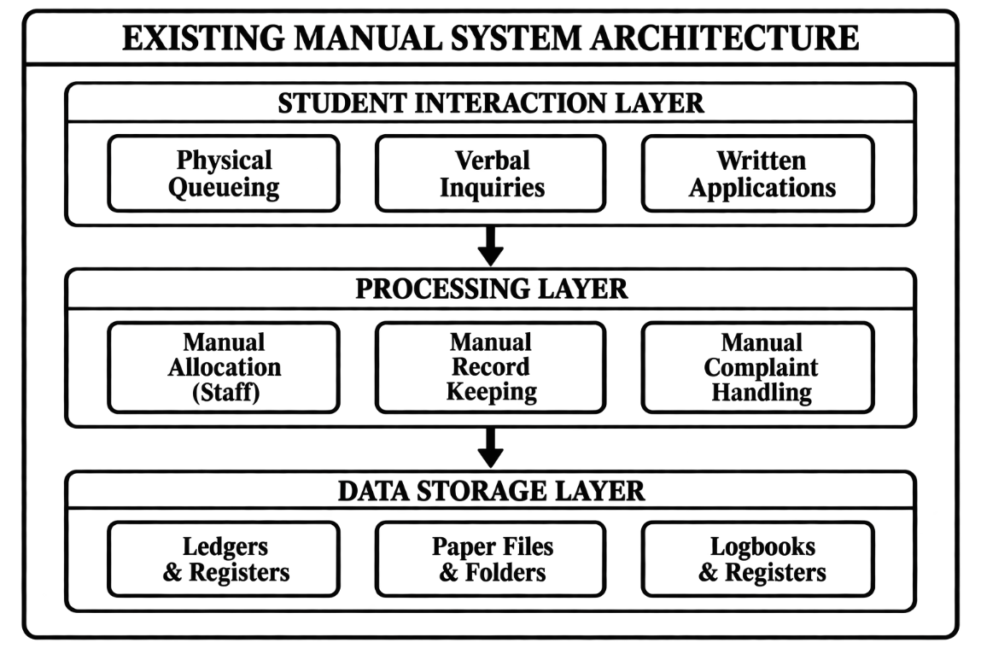
Figure 3.1: Architecture of Existing System

3.1.2 Constraints of the Existing System
The manual system suffers from numerous constraints:
Constraint Category | Specific Issues | Impact
Operational | Slow processing, data redundancy, no scalability | Students miss classes, staff overwhelmed
Security | Falsifiable logbooks, no audit trail, identity fraud | Security risks, disputes
Communication | No central platform, delayed updates, lost complaints | Student frustration, unresolved issues
Technical | No automation, error-prone processes, no remote access | Double allocation, inefficiency
Resource | High staff workload, paper costs, storage space | Wasted time and money

3.2 Analysis of the Proposed System
The proposed Student Hostel Management System is a web-based application designed to address these constraints through three integrated modules: rule-based room allocation, QR code attendance tracking, and complaint management.

3.2.1 Justification of the Proposed System
Justification Type | Benefits
Technical | Web-based platform, three-tier architecture, RESTful API, MongoDB for hierarchical data
Functional | Automated allocation, real-time occupancy, complaint tracking, OTP verification
Economic | Eliminates paper costs, reduces staff workload, prevents costly double allocation
Operational | 24/7 access, real-time updates, scalable, user-friendly interface

3.3 Method Adopted in the Study
3.3.1 Research Methodology
The Agile Software Development Methodology (Scrum framework) was adopted for this project. This methodology was chosen because:
- Iterative Development: The three core modules (allocation, attendance, complaints) could be developed and refined incrementally.
- User Involvement: Students and administrators were consulted throughout development.
- Flexibility: Requirements could be adjusted based on feedback.
- Early Delivery: Core functionalities were delivered early for testing.
- Risk Management: Issues were identified and resolved early in the cycle.
The following diagram illustrates the Agile development process:
text
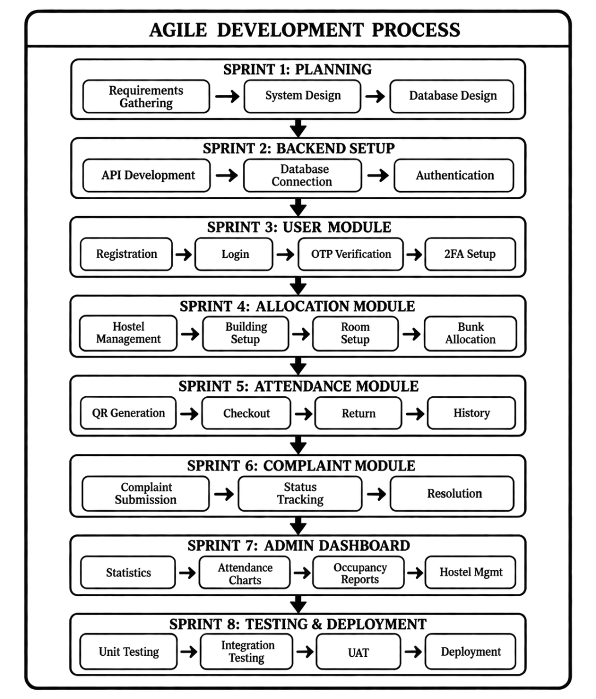
Figure 3.2: Agile Development Process

3.3.2 Research Approach
The research combined qualitative and quantitative methods:
Method | Details
Interviews | 3 hostel administrators, 5 porters, 15 students, 3 maintenance staff
Surveys | 50 students surveyed on waiting times, complaint resolution, satisfaction
Document Analysis | Allocation forms, logbooks, complaint registers, hostel policies

3.3.3 Development Tools
Category | Tools
Frontend | React.js, Redux Toolkit, Tailwind CSS, React Router, Lucide React
Backend | Node.js, Express.js, MongoDB, Mongoose, JWT, Bcrypt, Nodemailer
Deployment | Vercel (frontend), Railway (backend), MongoDB Atlas (database)

3.4 System Design
3.4.1 Architecture of the Proposed System
The system follows a three-tier client-server architecture:
1. Presentation Tier (Frontend - React.js) : Handles user interface and interactions. Provides separate interfaces for students, administrators, and porters.
2. Application Tier (Backend - Node.js/Express) : Contains business logic, authentication, and data processing. Includes controllers for users, hostel allocation, check-in/out, and complaints.
3. Data Tier (Database - MongoDB) : Stores all application data across eight collections: Users, Hostels, Buildings, Rooms, Bunks, CheckIns, Complaints, and Transactions.
The following diagram illustrates the complete system architecture:
text
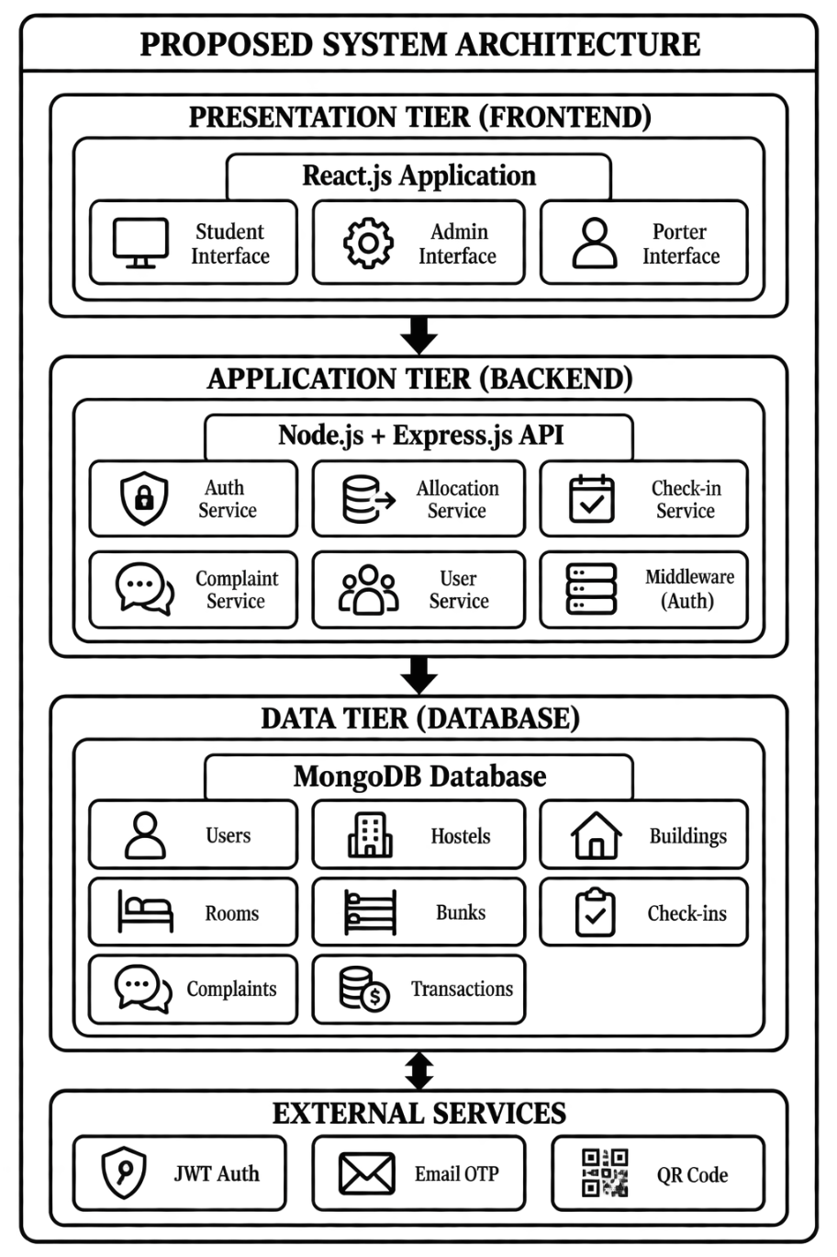
Figure 3.3: Proposed System Architecture

3.4.2 High Level Input Design
The system uses web forms with validation for data input:
Input Form | Key Fields | Validation
Student Registration | Full name, matric number, email, department, year of study, password | Required fields, unique email/matric, password min 6 chars
Hostel Creation | Hostel name, type (male/female), description | Required name, valid type
Building Creation | Select hostel, building name, description | Required hostel and building name
Room Creation | Select building, room number, bunk count, price | Required building, unique room number, bunk count ≥ 1
Complaint Submission | Title, description, category, anonymous flag | Required title and description
QR Scanner | Camera feed for QR code capture | Automatic JWT token validation

3.4.3 High Level Output Design
The system presents information to users through various interfaces:
Output | Key Information Displayed
Student Dashboard | Allocation status, QR code display, complaint count, recent activity
Admin Dashboard | Total students, checked in/out counts, weekly attendance chart, occupancy summary, recent activities, recent complaints
Complaint Tracking | Complaint details, current status, status timeline, action buttons
Hostel Management | Hierarchical view of hostels with buildings, rooms, and bunks; occupancy status

3.5 Database Design of the Proposed System
3.5.1 Entity-Relationship Diagram (ERD)
The database consists of eight collections with the following hierarchical structure:
- Hostel (1) → (M) Building
- Building (1) → (M) Room
- Room (1) → (M) Bunk
- Bunk (1) → (1) User (via allocatedBunk)
Additional relationships:
- User (1) → (M) CheckIn, Complaint, Transaction
- Bunk (1) → (M) CheckIn, Transaction
The following diagram illustrates the entity relationships:
text
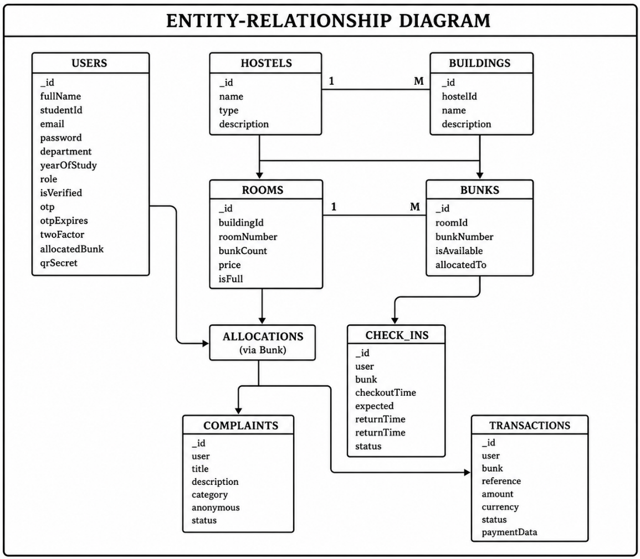
Figure 3.4: Entity-Relationship Diagram

3.5.2 Database Schema Description
1. Users Collection
Field | Type | Description | Constraints
_id | ObjectId | Unique identifier | Auto-generated
fullName | String | User's full name | Required
profilePicture | String | URL to profile image | Default: empty
studentId | String | Matriculation number | Required, Unique
institutionalEmail | String | School email | Required, Unique
department | String | Student's department | Required
yearOfStudy | Number | Current year (1-10) | Required
password | String | Hashed password | Required, min 6
role | String | user/admin/super_admin | Default: "user"
isVerified | Boolean | Email verification | Default: false
otp | String | One-time password | Default: null
otpExpires | Date | OTP expiration | Default: null
twoFactorEnabled | Boolean | 2FA status | Default: false
allocatedBunk | ObjectId | Reference to Bunk | Default: null
qrSecret | String | QR code secret | Default: null
createdAt | Date | Creation timestamp | Auto-generated
updatedAt | Date | Update timestamp | Auto-generated

2. Hostels Collection
Field | Type | Description | Constraints
_id | ObjectId | Unique identifier | Auto-generated
name | String | Hostel name | Required
type | String | male/female | Required
description | String | Additional details | Default: empty
createdAt | Date | Creation timestamp | Auto-generated
updatedAt | Date | Update timestamp | Auto-generated

3. Buildings Collection
Field | Type | Description | Constraints
_id | ObjectId | Unique identifier | Auto-generated
hostelId | ObjectId | Reference to Hostel | Required
name | String | Building name | Required
description | String | Additional details | Default: empty
createdAt | Date | Creation timestamp | Auto-generated
updatedAt | Date | Update timestamp | Auto-generated

4. Rooms Collection
Field | Type | Description | Constraints
_id | ObjectId | Unique identifier | Auto-generated
buildingId | ObjectId | Reference to Building | Required
roomNumber | String | Room identifier | Required
bunkCount | Number | Number of bunks | Required, min 1
price | Number | Room price | Default: 0
isFull | Boolean | Full status | Default: false
createdAt | Date | Creation timestamp | Auto-generated
updatedAt | Date | Update timestamp | Auto-generated

5. Bunks Collection
Field | Type | Description | Constraints
_id | ObjectId | Unique identifier | Auto-generated
roomId | ObjectId | Reference to Room | Required
bunkNumber | Number | Bunk identifier | Required, min 1
isAvailable | Boolean | Availability status | Default: true
allocatedTo | ObjectId | Reference to User | Default: null
createdAt | Date | Creation timestamp | Auto-generated
updatedAt | Date | Update timestamp | Auto-generated

6. CheckIns Collection
Field | Type | Description | Constraints
_id | ObjectId | Unique identifier | Auto-generated
user | ObjectId | Reference to User | Required
bunk | ObjectId | Reference to Bunk | Required
checkoutTime | Date | Time student left | Required
expectedReturnTime | Date | Expected return | Required
returnTime | Date | Actual return | Default: null
status | String | in/out | Default: "out"
createdAt | Date | Creation timestamp | Auto-generated
updatedAt | Date | Update timestamp | Auto-generated

7. Complaints Collection
Field | Type | Description | Constraints
_id | ObjectId | Unique identifier | Auto-generated
user | ObjectId | Reference to User | Required
title | String | Complaint title | Required
description | String | Complaint details | Required
category | String | Category | Default: "General"
anonymous | Boolean | Anonymous flag | Default: false
status | String | pending/read/done | Default: "pending"
createdAt | Date | Creation timestamp | Auto-generated
updatedAt | Date | Update timestamp | Auto-generated

8. Transactions Collection
Field | Type | Description | Constraints
_id | ObjectId | Unique identifier | Auto-generated
user | ObjectId | Reference to User | Required
bunk | ObjectId | Reference to Bunk | Required
reference | String | Transaction reference | Required, Unique
amount | Number | Payment amount | Required
currency | String | Currency code | Default: "NGN"
status | String | pending/paid/failed/refunded | Default: "pending"
paymentGateway | String | Gateway used | Default: "paystack"
paymentData | Mixed | Gateway response | Default: {}
createdAt | Date | Creation timestamp | Auto-generated
updatedAt | Date | Update timestamp | Auto-generated

3.5.3 Database Relationships Summary
Relationship | Type | Description
Hostel → Building | One-to-Many | A hostel has multiple buildings
Building → Room | One-to-Many | A building has multiple rooms
Room → Bunk | One-to-Many | A room has multiple bunks
Bunk → User | One-to-One | A bunk is allocated to one user
User → CheckIn | One-to-Many | A user has multiple check-in records
User → Complaint | One-to-Many | A user submits multiple complaints
User → Transaction | One-to-Many | A user has multiple transactions
Bunk → CheckIn | One-to-Many | A bunk has multiple check-in records
Bunk → Transaction | One-to-Many | A bunk has multiple transactions

3.5.4 Database Indexes
The following indexes ensure performance optimization:
Collection | Index | Purpose
Users | studentId (Unique) | Fast student lookup
Users | institutionalEmail (Unique) | Fast email lookup
Bunks | roomId + bunkNumber (Unique) | Prevent duplicate bunk numbers
Rooms | buildingId + roomNumber (Unique) | Prevent duplicate room numbers
Transactions | reference (Unique) | Fast transaction lookup
Transactions | user + createdAt | Fast user transaction history

3.6 Summary of Chapter Three
This chapter presented the analysis and design of the Student Hostel Management System based on the actual implementation reviewed from the project code.
The existing manual system was analysed and found to have significant constraints including slow processing, data redundancy, security vulnerabilities, lack of transparency, and high resource requirements. The proposed system addresses these through a three-tier architecture with web-based access, automated allocation, QR code attendance tracking, and complaint management.
The Agile development methodology was adopted with iterative development, user involvement, and early delivery of core functionalities. The system architecture comprises a React.js frontend, Node.js/Express backend, and MongoDB database with eight collections organized in a hierarchical structure.
Key design elements include registration and management forms with validation, dashboards displaying real-time statistics, and a comprehensive database schema with proper relationships and indexes.

CHAPTER FOUR
SYSTEM IMPLEMENTATION

4.1 Choice of Implementation Platform
The Student Hostel Management System was implemented using a three-tier client-server architecture with modern web technologies, consistent with the design established in Chapter Three.

4.1.1 Frontend Platform
The frontend was developed using React.js, a JavaScript library for building component-based user interfaces. React.js enabled the creation of separate, responsive interfaces for students, administrators, and porters. React Router managed navigation between pages, providing a single-page application experience. Redux Toolkit was employed for centralized state management, handling user authentication, allocation data, complaint statuses, and attendance records across the application. Tailwind CSS provided utility-first styling for responsive, professional interfaces accessible on both mobile and desktop devices. Lucide React supplied icon components for navigation elements and action buttons.

4.1.2 Backend Platform
The backend was implemented using Node.js with Express.js. Node.js allowed JavaScript to be used on the server side, unifying the language across the entire application stack. Express.js provided a lightweight framework for building RESTful APIs, handling routing, middleware configuration, and request/response processing.
JWT (JSON Web Tokens) was implemented for authentication and authorization. Upon successful login, the backend generated a JWT containing user identification and role information, included in subsequent API requests for verification.
Bcrypt was used for password hashing, ensuring passwords were never stored in plain text. Nodemailer was integrated for email functionality, sending verification OTPs to students during registration and notifications about allocation and complaint updates.
Mongoose served as the ODM (Object Data Modeling) library for MongoDB, providing schema-based data modeling with validation rules for all eight collections.

4.1.3 Database Platform
MongoDB was selected as the database management system. As a NoSQL document database, MongoDB stores data in JSON-like documents, aligning naturally with the JavaScript/Node.js ecosystem. MongoDB Atlas provided cloud-based database hosting with automated backups and monitoring.

4.1.4 Deployment Platform
Vercel was used for frontend deployment, Railway for backend deployment, and MongoDB Atlas for database hosting. This strategy allowed the three tiers to be hosted independently while communicating through defined interfaces.

4.1.5 Justification of Implementation Platform
The selected technologies were appropriate for the project requirements. The web-based approach ensured accessibility from different devices without installation. React.js enabled modular development of separate user interfaces. Redux Toolkit provided consistent state management. Node.js and Express.js offered efficient API development with JavaScript throughout the stack. MongoDB supported the hierarchical data structure of hostels, buildings, rooms, and bunks. JWT and Bcrypt provided robust authentication and security. The deployment platforms offered reliable hosting with minimal configuration.

4.2 Implementation Architecture
The three-tier client-server architecture was implemented as follows:
Presentation Tier: The React.js frontend rendered user interfaces based on state changes managed by Redux Toolkit. It communicated with the backend exclusively through HTTP requests to the RESTful API.
Application Tier: The Node.js/Express backend exposed API endpoints for user management, allocation processing, attendance tracking, and complaint handling. It validated data, applied business rules, and interacted with the database through Mongoose models.
Data Tier: MongoDB Atlas stored data across eight collections: Users, Hostels, Buildings, Rooms, Bunks, CheckIns, Complaints, and Transactions.
Communication Flow:
- User performed an action in the frontend.
- Frontend validated input and sent API request to backend.
- Backend authenticated user via JWT and validated data.
- Backend applied business logic and performed database operations.
- Database returned result to backend.
- Backend formatted response and sent to frontend.
- Frontend updated state and re-rendered interface.

4.2.1 Student and User Management
Registration forms collected student information including full name, matriculation number, institutional email, department, year of study, and password. The backend validated input, checked uniqueness of email and student ID, and created user documents. Passwords were hashed with bcrypt. OTPs were generated and sent via Nodemailer for email verification. Login used email and password, with bcrypt verification and JWT generation. Role-based access control restricted functionality based on user role (student, porter, administrator). Profile management allowed students to view and update their information.

4.2.2 Hostel and Room Management
Administrators created hostels through the admin interface, specifying name and type (male/female). Buildings were created within hostels. Rooms were created within buildings with room number, bunk count, and price. When rooms were created, the system automatically generated bunk documents based on the specified bunk count, each initially marked as available.

4.2.3 Rule-Based Room Allocation
The allocation system implemented three rules:
- Gender Separation: Only hostels and rooms matching the student's gender were considered.
- First-Come-First-Served: Allocation requests were processed chronologically.
- Student Level Priority: Final-year students received priority, followed by other years.
The allocation process:
- Student submitted allocation request.
- Backend retrieved student information (gender, year of study).
- System queried available bunks in gender-appropriate hostels.
- Available bunks were ordered by request timestamp and student level.
- First available bunk was selected and marked as allocated.
- Student's allocatedBunk field was updated.
- Allocation details were returned to the frontend.
Double allocation was prevented through unique indexes on bunk identifiers, atomic update operations, and verification of bunk availability before allocation.

4.2.4 QR Code Attendance Tracking
Each student received a unique QR code generated from user identification data. QR codes were displayed in the student dashboard.
Check-In Process:
- Porter or student scanned QR code using device camera.
- Decoded information sent to /api/checkins/checkin.
- Backend authenticated request and verified QR data.
- System checked student's current status; if not already checked in, new CheckIn document created.
- Document recorded user ID, bunk ID, current time as checkoutTime, status "in".
- Success response returned.
Check-Out Process:
- QR code scanned and sent to /api/checkins/checkout.
- System found most recent check-in without returnTime.
- Updated CheckIn with returnTime (current time) and status "out".
Attendance Monitoring: Administrators and porters could view current occupancy counts, individual student status, attendance history, and emergency roll call lists.

4.2.5 Complaint Management
Students submitted complaints through forms collecting title, description, category, and anonymous flag. The backend created complaint documents with status "pending".
Complaint lifecycle:
- Pending: Submitted, not yet reviewed.
- Read: Reviewed by administrator.
- In Progress: Assigned and being worked on.
- Done: Completed.
Students tracked complaint statuses through the dashboard. Administrators managed complaints through a dedicated interface allowing status updates and notes.

4.2.6 Database Implementation
Eight collections were implemented with Mongoose schemas, validation rules, and relationships:
- Users: Student and administrator profiles with references to allocatedBunk.
- Hostels: Hostel information including type for gender filtering.
- Buildings: Linked to Hostels via hostelId.
- Rooms: Linked to Buildings via buildingId with bunkCount.
- Bunks: Linked to Rooms via roomId with isAvailable and allocatedTo.
- CheckIns: Linked to Users and Bunks with status and timestamps.
- Complaints: Linked to Users with status tracking.
- Transactions: Linked to Users and Bunks with payment information.
Indexes were implemented on studentId, institutionalEmail, bunk uniqueness, room uniqueness, transaction reference, and transaction history for performance optimization.

4.3 System Testing
System testing was conducted in a controlled environment using simulated data, consistent with the limitations identified in Chapter One. Testing covered functional, validation, integration, and user interface testing.
Test ID | Module/Function | Expected Result | Status
TC-001 | Student Registration | User created, OTP sent | Pass
TC-002 | Duplicate Registration | Error message | Pass
TC-003 | Email Verification | User verified | Pass
TC-004 | Incorrect OTP | Error message | Pass
TC-005 | User Login | JWT generated | Pass
TC-006 | Incorrect Login | Error message | Pass
TC-007 | Hostel Creation | Hostel created | Pass
TC-008 | Building Creation | Building created | Pass
TC-009 | Room Creation | Room and bunks created | Pass
TC-010 | Duplicate Room | Validation error | Pass
TC-011 | Gender-Based Allocation | Appropriate hostel allocated | Pass
TC-012 | Double Allocation Prevention | Single allocation succeeds | Pass
TC-013 | QR Check-In | CheckIn recorded | Pass
TC-014 | QR Check-Out | CheckOut recorded | Pass
TC-015 | Complaint Submission | Complaint created | Pass
TC-016 | Complaint Status Update | Status changed | Pass
TC-017 | Role-Based Access | Access denied | Pass
Functional Testing: All test cases executed successfully. Registration included email verification. Allocation processed gender-based filtering correctly and prevented double allocation. QR scanning recorded check-ins and check-outs accurately. Complaint management enabled submission and status tracking.
Validation Testing: Forms prevented invalid data submission at both frontend and backend levels. Database constraints prevented duplicate entries.
Integration Testing: Three tiers integrated successfully. Frontend communicated correctly with backend API. Backend interacted correctly with MongoDB. Data flowed consistently through the system.
User Interface Testing: Interfaces displayed correctly with responsive design. Navigation was intuitive.

4.4 Performance Evaluation
Performance Area | Observation/Result
Registration | Completed with OTP email sent within acceptable time
Email Verification | Processed without significant delay
User Login | JWT returned quickly
Hostel Management | Processed without errors
Room Allocation | Processed correctly with gender filtering and availability checks
Double Allocation Prevention | Effectively prevented conflicts
QR Check-In | Recorded correctly with timestamp
QR Check-Out | Recorded correctly with timestamp
Attendance Monitoring | Real-time occupancy displayed
Complaint Management | Submission and tracking functional
Dashboard Loading | Responsive
Navigation | Smooth between sections

The system demonstrated acceptable response times for typical operations. Database queries for allocation, attendance, and complaints completed without noticeable delays. Error handling provided appropriate feedback. Usability was satisfactory with intuitive interfaces.
As acknowledged in Chapter One, performance evaluation was conducted in a controlled, small-scale environment using simulated data. Full validation under heavy concurrent user loads was not performed.

4.5 Discussion of Results
The implemented system successfully addresses the problems identified in the existing manual hostel administration system and achieves the objectives stated in Chapter One.
Objective 1: Digital room allocation – The system provides digital allocation without physical presence or manual paperwork, eliminating long queues.
Objective 2: Allocation rules – Gender separation, first-come-first-served, and student level priority were implemented, ensuring fairness and reducing human bias.
Objective 3: Double allocation prevention – Database validation, atomic updates, and availability checks prevent double allocation errors that cause conflicts.
Objective 4: QR code check-in/check-out – QR-based attendance provides fast, reliable recording of student movement, replacing unreliable paper logbooks.
Objective 5: Digital movement records – The CheckIns collection maintains accurate digital records with complete audit trails.
Objective 6: Complaint system – Online complaint submission ensures issues are properly recorded and not lost.
Objective 7: Complaint status tracking – Real-time status tracking provides transparency and accountability.
Objective 8: Communication – The platform provides a central channel for allocation and complaint-related communication.
Objective 9: Testing – Testing in a controlled environment demonstrated correct system operation.
The system addresses the problems identified in Chapter One: it eliminates queuing and paperwork for allocation, provides real-time occupancy monitoring for security, ensures complaints are properly tracked, and offers transparency through a centralized platform.

4.6 Documentation
Technical Documentation: System architecture, frontend structure, backend API, database schema, deployment procedures, and installation guide. Source code is maintained in version control with comments.
User Documentation: Student user guide covering registration, allocation, QR check-in, complaints, and status tracking. Administrator user guide covering hostel and room management, allocation configuration, attendance monitoring, and complaint handling. Porter user guide covering QR scanning and attendance monitoring.

4.7 System Setup and User Manual
4.7.1 System Requirements
Hardware: Computer/laptop/mobile device with internet access, camera-enabled device for QR scanning, adequate RAM and storage.
Software: Modern web browser (Chrome, Firefox, Edge, Safari), JavaScript enabled.
For Local Development: Node.js (version 14+), npm/yarn, MongoDB (local or Atlas), Git, code editor.

4.7.2 System Setup
Accessing Deployed Application:
- Open modern web browser.
- Navigate to frontend URL.
- Login or register as needed.
Local Development Setup:
- Clone repository: git clone [repository-url]
- Backend: Navigate to backend directory, install dependencies, create .env with MONGODB_URI, JWT_SECRET, EMAIL_USER, EMAIL_PASS, PORT.
- Start backend: npm start
- Frontend: Navigate to frontend directory, install dependencies, create .env with REACT_APP_API_URL.
- Start frontend: npm start
- Access at http://localhost:3000

4.7.3 Student User Manual
Step 1: Access – Open browser, navigate to system URL.
Step 2: Register – Click Register, fill in full name, matriculation number, institutional email, department, year of study, password. Submit.
Step 3: Verify – Check email for OTP, enter on verification page, click Verify.
Step 4: Login – Enter institutional email and password, click Login.
Step 5: Dashboard – View allocation status, QR code, complaint count, recent activity.
Step 6: Apply for Allocation – Click "Apply for Allocation" if not allocated. System processes request based on rules.
Step 7: View Allocation – Navigate to "My Allocation" to see hostel, building, room, bunk.
Step 8: QR Code – Navigate to "My QR Code" to view unique QR code.
Step 9: Check In – Show QR code to porter or scan at scanning point to record entry.
Step 10: Check Out – Scan QR code at scanning point to record exit.
Step 11: Submit Complaint – Navigate to Complaints, click Submit, fill in title, description, category, anonymous option, submit.
Step 12: Track Complaint – View complaints list with statuses in Complaints section.
4.7.4 Administrator User Manual
Step 1: Login – Access system, login with administrator credentials.
Step 2: Dashboard – View total students, current check-in counts, occupancy summary, recent activities, recent complaints.
Step 3: Manage Hostels – Navigate to Hostels, click Create Hostel, enter name, type, description, save.
Step 4: Manage Buildings – Select hostel, click Add Building, enter name, description, save.
Step 5: Manage Rooms – Select building, click Add Room, enter room number, bunk count, price, save.
Step 6: Manage Bunks – Bunks auto-created. View availability in room details.
Step 7: Monitor Attendance – Navigate to Attendance, view current occupancy, check-in list, history.
Step 8: Handle Complaints – Navigate to Complaints, view list, click to review, update status (Read, In Progress, Done), add notes.
Step 9: Manage Users – Navigate to Students, view list, search, click for details.
Step 10: Logout – Click Logout to exit.

CHAPTER FIVE
SUMMARY AND CONCLUSION AND RECOMMENDATION

5.1 Summary
The study was undertaken to address the significant challenges associated with manual hostel administration in many Nigerian universities. The background to the study established that enrolment has surged while bed capacity has remained fixed, overwhelming both students and staff. The existing manual methods of room allocation, attendance tracking, and complaint management were identified as being slow, error-prone, unreliable, and lacking transparency. Students endure long queues and paperwork during allocation, while double allocation of beds often leads to conflicts. Paper logbooks for tracking movement are easily falsified or lost, compromising security and making it difficult to know exactly who is inside the hostel at any moment. Maintenance complaints reported verbally or on paper slips frequently disappear, leaving issues unresolved and facilities in decay.
The primary aim of the study was to design and develop a Student Hostel Management System incorporating rule-based room allocation, QR code attendance tracking, and complaint management. The specific objectives were to develop a digital system for allocating hostel rooms; implement allocation rules including first-come-first-served, student level, and gender separation; implement automatic database validation to prevent double allocation; create a QR code check-in and check-out system; develop accurate digital records of student movement; implement a complaint system for reporting maintenance issues; provide real-time complaint status tracking; evaluate the system's effectiveness in improving communication; and test the system's functionality and performance in a controlled environment.
The literature review examined information systems, hostel management systems, rule-based allocation systems, QR code technology, attendance tracking systems, complaint management systems, web-based systems, and database management systems. The review revealed that while several researchers had developed systems for individual functions such as complaint management, hostel allocation, or attendance tracking, none combined all three essential functions in an integrated web-based platform. This gap justified the development of the proposed system.
The Agile Software Development Methodology using the Scrum framework was adopted for the project. This methodology was chosen for its iterative development approach, user involvement, flexibility, early delivery of core functionalities, and risk management capabilities. The research combined qualitative and quantitative methods, including interviews with hostel administrators, porters, students, and maintenance staff, as well as surveys and document analysis of existing allocation forms, logbooks, and complaint registers.
The system was implemented using a three-tier client-server architecture. The presentation tier was developed with React.js, Redux Toolkit, Tailwind CSS, React Router, and Lucide React. The application tier was implemented using Node.js, Express.js, JWT for authentication, Bcrypt for password hashing, and Nodemailer for email functionality. The data tier used MongoDB with Mongoose as the ODM library, hosted on MongoDB Atlas. The system was deployed with Vercel for the frontend and Railway for the backend.
The database consisted of eight collections: Users, Hostels, Buildings, Rooms, Bunks, CheckIns, Complaints, and Transactions. These collections supported the hierarchical structure of hostels containing buildings, buildings containing rooms, and rooms containing bunks, with appropriate relationships between students and their allocations, attendance records, and complaints.
Key features implemented included student registration with email verification, role-based access control, hostel and room management, rule-based allocation with gender separation, first-come-first-served processing, and student level priority. QR code generation and scanning enabled efficient check-in and check-out, providing real-time occupancy monitoring. The complaint management system allowed students to submit issues online and track their status through pending, read, in progress, and done stages.
System testing covered functional, validation, integration, and user interface testing. All test cases executed successfully, demonstrating that the system operated as expected. The performance evaluation showed acceptable response times for typical operations, with database queries for allocation, attendance, and complaints completing without noticeable delays. However, consistent with the study's limitations, testing was conducted in a controlled, small-scale environment using simulated data, and full validation under heavy concurrent user loads was not performed.
Overall, the developed system successfully provides an integrated digital approach to hostel allocation, attendance monitoring, and complaint management, addressing the major problems identified in Chapter One. The system offers a practical alternative to the manual processes that have long characterized hostel administration in many Nigerian universities.

5.2 Conclusion
The study successfully achieved its primary aim of designing and developing a Student Hostel Management System incorporating rule-based room allocation, QR code attendance tracking, and complaint management. The implemented system provides a comprehensive digital solution that addresses the significant challenges associated with manual hostel administration.
The system successfully provides digital room allocation, eliminating the need for students to endure long queues and complete cumbersome paperwork. The rule-based allocation functionality automatically enforces first-come-first-served, student level priority, and gender separation, ensuring fairness and removing human bias from the allocation process. The automatic database validation and bunk availability checks effectively prevent double allocation, addressing a critical problem that often causes conflicts among students.
The QR code check-in and check-out system provides fast, reliable recording of student movement, replacing unreliable paper logbooks. This functionality enables real-time occupancy monitoring, enhancing security and facilitating rapid headcounts during emergencies. The digital records maintained in the CheckIns collection create a complete audit trail of student entry and exit.
The complaint management module enables students to report maintenance issues online and track their resolution progress. The status-based workflow - pending, read, in progress, and done - provides transparency and accountability, ensuring that complaints are properly recorded, assigned, and addressed. This addresses the problem of complaints being lost or ignored under manual systems.
The system's web-based architecture ensures accessibility from any device with an internet connection, eliminating the need for software installation. The role-based access control ensures that students, porters, and administrators have appropriate permissions, maintaining security and data integrity.
The testing conducted demonstrated that the system functions correctly in a controlled environment. All test cases passed, confirming the reliability of registration, authentication, allocation, QR attendance, complaint management, and role-based access control. The performance evaluation indicated acceptable response times for typical operations.
However, the study acknowledges that performance evaluation was conducted under controlled, small-scale conditions using simulated data. The system's performance under heavy concurrent user loads typical of large institutions was not fully validated. This limitation does not diminish the significance of the implemented system but highlights the need for further testing before institution-wide deployment.
In conclusion, the Student Hostel Management System provides a practical, integrated digital solution that addresses the inefficiencies, errors, security concerns, and lack of transparency associated with manual hostel administration. The system demonstrates the potential of digital transformation to improve student welfare and institutional effectiveness in Nigerian universities.

5.3 Recommendations
Based on the findings and implementation experience of this project, the following recommendations are made:
1. Institutional Adoption
Universities and higher education institutions should consider adopting the Student Hostel Management System to replace or significantly reduce manual hostel allocation, paper attendance records, and informal complaint reporting. The system offers clear advantages in terms of efficiency, accuracy, transparency, and accountability.
2. Proper Data Management
Institutions should establish proper procedures for maintaining accurate student, hostel, room, bunk, attendance, and complaint information. The effectiveness of the system depends on the quality and accuracy of the data entered. Regular data validation and audit processes should be implemented.
3. Reliable Internet and Infrastructure
Since the system is web-based and depends on internet connectivity and server infrastructure, institutions should ensure adequate and reliable network connectivity. Investment in stable internet connections, reliable power supply, and appropriate server hosting is essential for successful deployment and operation.
4. User Training
Comprehensive training should be provided to students, administrators, porters, and relevant staff before full deployment. Users should understand how to register, apply for allocation, use QR codes for check-in and check-out, submit and track complaints, and perform administrative functions. Training will ensure effective use of the platform and maximize its benefits.
5. Security and Access Control
Institutions should continue to enforce authentication, role-based access control, secure password handling, and appropriate protection of student information. Regular security audits and updates should be conducted to safeguard sensitive data.
6. QR Attendance Administration
Proper procedures for QR scanning and attendance monitoring should be established to ensure that check-in and check-out records remain reliable. Porter training should emphasize the importance of accurate scanning and the significance of maintaining accurate occupancy records.
7. Complaint Monitoring
Administrators and maintenance personnel should regularly monitor complaint submissions and update statuses promptly. The transparency intended by the system can only be achieved if complaints are addressed in a timely manner and students receive appropriate feedback on resolution progress.
8. Backup and Maintenance
Regular database backups, system monitoring, software maintenance, and timely updates should be implemented. Institutions should establish procedures for disaster recovery and business continuity to ensure the system remains available and reliable.
9. Scalability Testing
Further testing under larger and more realistic user loads should be conducted before institution-wide deployment. The current project was tested in a controlled, small-scale environment; additional testing will provide greater confidence in the system's ability to handle the demands of large institutions.
10. Continuous Improvement
Periodic review of allocation rules and system requirements should be conducted to ensure that the platform remains aligned with institutional hostel policies and evolving needs. Feedback from students and staff should be collected and used to inform system improvements.

5.4 Suggestions for Future Studies
Based on the limitations and scope of this project, the following areas are suggested for future research and development:
1. Large-Scale Performance Evaluation
Future studies should conduct comprehensive performance evaluation under heavy concurrent user loads and realistic institutional workloads. This would provide empirical data on the system's scalability, response times, and reliability under conditions typical of large Nigerian universities.
2. Integration with Institutional Systems
Future development should explore integration with existing institutional systems such as academic records, student information systems, and financial systems. The current application operates as a standalone system; integration would enable seamless data flow and reduce redundant data entry.
3. Online Payment Gateway Integration
The present scope excludes direct online payment gateway integration, with payment confirmations handled manually. Future work should integrate payment gateways such as Paystack or Flutterwave to enable online payment processing for hostel fees and other charges.
4. Advanced Biometric Authentication
Future research could investigate the integration of biometric authentication methods such as fingerprint or facial recognition, which were explicitly outside the current scope. Biometric systems could provide enhanced security and prevent the sharing of QR codes between students.
5. GPS and Location-Based Functionality
External GPS tracking was excluded from the current study. Future work could explore GPS-based functionality for monitoring student movements outside the hostel, where ethically justified and appropriate, or for location-based services such as finding nearby maintenance personnel.
6. Artificial Intelligence and Predictive Analytics
AI-based predictive accommodation needs were outside the current scope. Future research could apply machine learning techniques to forecast accommodation demand, identify occupancy patterns, optimize allocation decisions, and predict maintenance issues before they escalate.
7. Offline or Low-Connectivity Functionality
The web-based nature of the system requires internet connectivity. Future development could explore offline functionality or progressive web application features to improve usability in areas with unreliable internet connectivity.
8. Expanded Complaint Management
Future work could enhance the complaint management module with richer maintenance workflows, including automatic assignment based on complaint type, notifications to relevant personnel, prioritization algorithms, and resolution verification with photo evidence.
9. Comprehensive Usability Studies
Usability studies involving larger numbers of actual hostel residents and staff could provide valuable insights into user experience, adoption barriers, and areas requiring improvement. Such studies would complement the functional testing conducted in this project.
10. Comparative Studies
Comparative studies evaluating the proposed system against other hostel management platforms or alternative allocation and attendance technologies could provide evidence of the relative advantages and limitations of different approaches, informing future development decisions.
These suggested areas for future studies represent opportunities to build upon the foundation established by this project and to further advance the digital transformation of hostel administration in Nigerian higher education institutions.

References
Anusiuba, O. I. A., Karim, U., Ekwealor, O. U., & Igbonekwu, J. O. (2021). Design and implementation of a tertiary institution web-based student complaint management system. International Journal of Software & Hardware Research in Engineering (IJSHRE)
Eneh, A. U., & Ugwu, R. O. (2022)
Ezstays. (2025). Ezstays Warden
Ibrahim, G. M., Okonkwo, L. N., & Ige, F. T. (2020)
Muneeb1030. (2024). Hostel Management System
NED. (2025). NERD: a National Multi-institutional Digitisation & Quality Assurance System
Nwekori, F. E., & Ogbaga, I. N. (2025). Design and implementation of a web-based food ordering platform for academic environments. Journal of Digital Food, Energy & Water Systems (JD-FEWS)
Ohayi, C. (2025). Design and implementation of an online hostel management system (a case study of Abia State Polytechnic Aba, Abia State)
Okonkwo, L. N., & Ibrahim, G. M. (2021)
Onyema, E. M. (2019). Opportunities and challenges of the use of mobile phone technology in teaching and learning in Nigeria, a review. International Journal of Research and Innovation in Engineering (IJREI)
Perlego. (2016). Perlego: Online library for academic textbooks
Qnnect. (2025). Qnnect: QR code attendance tracking system
RentOk. (2026). RentOk: Property management software
Saylor Academy. (2021). BUS206: Management information systems
Shaheen, S. (2016). Hostel management system. LAP Lambert Academic Publishing.
University of Nigeria, Nsukka. (2024). Hostel allocation notice

APPENDICES
SOURCE CODE

APPENDIX A
A.1 Authentication and Registration Source Code
- backend/middleware/auth.js: JWT authentication middleware
import jwt from "jsonwebtoken";
import asyncHandler from "express-async-handler";
import User from "../models/userModel.js";
const protect = asyncHandler(async (req, res, next) => {
let token;
if (
req.headers.authorization &&
req.headers.authorization.startsWith("Bearer ")
) {
token = req.headers.authorization.split(" ")[1];
} else if (req.cookies?.jwt) {
token = req.cookies.jwt;
}
if (!token) {
res.status(401);
throw new Error("Not authorized, no token");
}
try {
const decoded = jwt.verify(token, process.env.JWT_SECRET);
const user = await User.findById(decoded.userId).select("-password");
if (!user) {
res.status(401);
throw new Error("User not found");
}
req.user = user;
next();
} catch (error) {
res.status(401);
throw new Error("Not authorized, token failed");
}
});
export { protect };

A.2 Rule-Based Hostel Allocation Source Code
- backend/models/Hostel.js: Hostel schema
import mongoose from "mongoose";
const hostelSchema = new mongoose.Schema(
{
name: {
type: String,
required: true,
trim: true,
},
type: {
type: String,
enum: ["male", "female"],
required: true,
},
description: {
type: String,
default: "",
},
},
{ timestamps: true }
);
const Hostel = mongoose.model("Hostel", hostelSchema);
export default Hostel;

A.3 API Routes
- backend/routes/userRoutes.js — User management routes
import express from "express";
import {
registerUser,
loginUser,
verifyOTP,
forgotPassword,
resetPassword,
getUserInfo,
logoutUser,
updateProfile,
toggleTwoFactor,
getAllStudents,
} from "../controllers/userController.js";
import { protect } from "../middleware/authMiddleware.js";
import multer from "multer";
import { v2 as cloudinary } from "cloudinary";
import { CloudinaryStorage } from "multer-storage-cloudinary";
const router = express.Router();
// Cloudinary config
cloudinary.config({
cloud_name: process.env.CLOUD_NAME,
api_key: process.env.API_KEY,
api_secret: process.env.API_SECRET,
});
const storage = new CloudinaryStorage({
cloudinary,
params: {
folder: "CampusResolveProfiles",
allowed_formats: ["jpg", "png", "jpeg"],
transformation: [{ width: 300, height: 300, crop: "fill" }],
},
});
const upload = multer({ storage });
// Public routes
router.post("/register", registerUser);
router.post("/login", loginUser);
router.post("/verify-otp", verifyOTP);
router.post("/forgot-password", forgotPassword);
router.post("/reset-password", resetPassword);
// Private routes (require authentication)
router.use(protect); // All routes below this line require a valid token
// NEW: Get all students (admin only — or just protected)
router.get("/", getAllStudents);
router.get("/me", getUserInfo);
router.post("/logout", logoutUser);
router.put("/update", upload.single("profilePicture"), updateProfile);
router.put("/toggle-2fa", toggleTwoFactor);
export default router;

A.4 Frontend State Management and Configuration
- frontend/src/store/authSlice.js: Authentication state management
import { createSlice } from "@reduxjs/toolkit";
const initialState = {
userInfo: localStorage.getItem('userInfo') ? JSON.parse(localStorage.getItem
('userInfo')) : null
}
const authSlice = createSlice({
name: 'auth',
initialState,
reducers: {
//For Users
setCredentials: (state, action) => {
state.userInfo = action.payload;
localStorage.setItem('userInfo', JSON.stringify(action.payload));
},
//for Logout
logout: (state, action) => {
state.userInfo = null;
localStorage.removeItem('userInfo');
}
}
});
export const { setCredentials, logout } = authSlice.actions;
export default authSlice.reducer;

APPENDIX B
SYSTEM SNAPSHOTS

STUDENT INTERFACE
Figure B.1: Student Login Interface
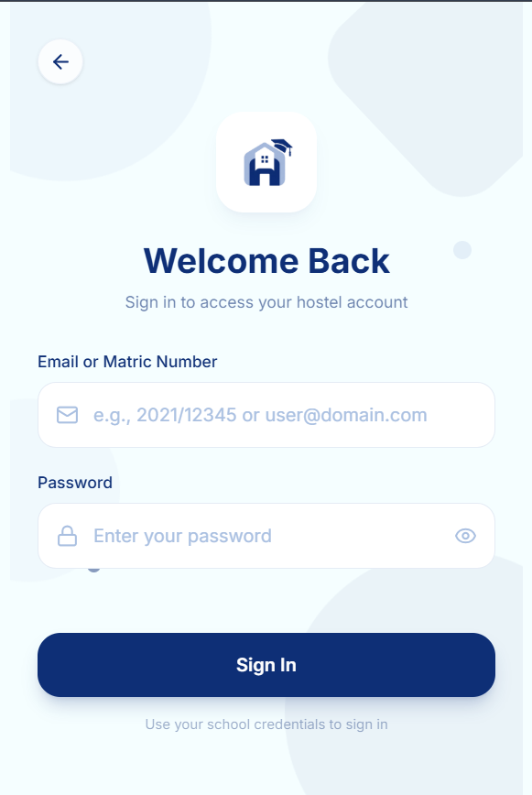

Figure B.2: Complaint Submission Interface
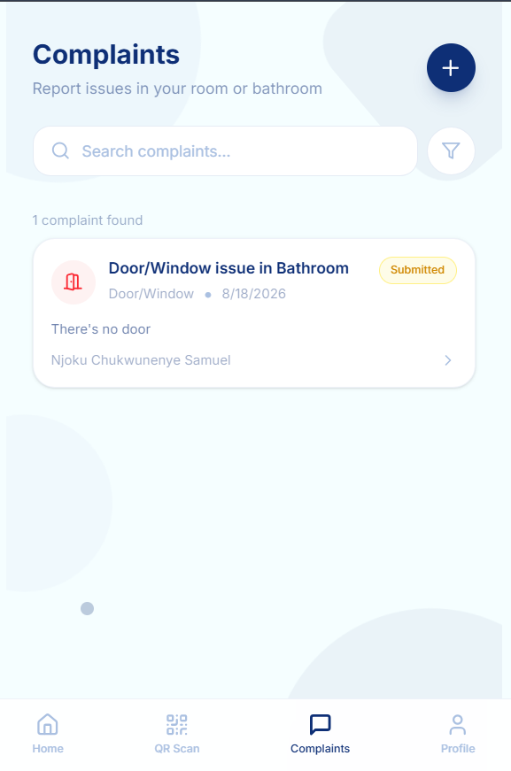

ADMINISTRATOR INTERFACE
Figure B.9: Administrator Dashboard
[Actual screenshot required — shows total students, current check-in counts, occupancy summary, recent activity, and recent complaints]

Figure B.10: Hostel, Building and Room Management Interface
[Actual screenshot required — shows the hierarchical management interface: Hostel → Building → Room → Bunk]

Figure B.11: Attendance Monitoring Interface
[Actual screenshot required — shows current occupancy, check-in records, check-out records, and student status]

Figure B.12: Administrator Complaint Management Interface
[Actual screenshot required — shows complaint list with status workflow: pending → read → in progress → done]

